**Diagrams and plots implemented by code**

1. Зображення, що містить текст, знімок екрана, Шрифт, дизайн

   Автоматично згенерований опис Frequency table: it divides all amount of people by age and shows us how many people are in each formed group:

Frequency table

1. Histogram of age frequencies: this histogram visualizes data from previous frequency table.

Histogram of age frequencies

1. Зображення, що містить знімок екрана, схема, дизайн

   Автоматично згенерований описContour plot: represent relationship between age of people and duration of sleep.

Contour plot

1. 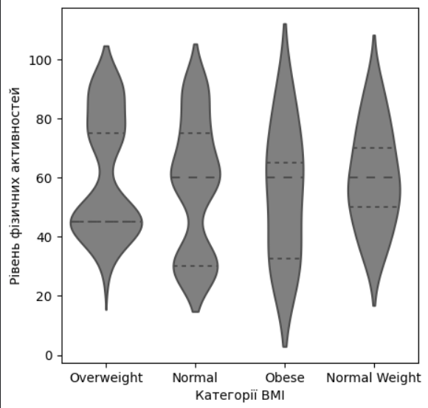Violin plot: this type of plot combines aspects of a box plot and a density plot and shows the distribution of physical activity levels across different BMI categories.

Violin plot

1. Зображення, що містить схема, текст, знімок екрана, Прямокутник

   Автоматично згенерований описBox plot: this type of plot is used to display the distribution of sleep duration across different occupations based on five-number summary: minimum, first quartile, median, third quartile and maximum.
2. Correlation matrix: shows the correlation coefficients between multiple variables in a dataset: age, physical activity level, stress level, daily steps and sleep duration. Coefficient ranges from -1 to 1: if it`s positive, then as one variable increases, the other variable increases too; if it`s negative, then as one variable increases, the other tends to decrease. If coefficient is equal to 0, then there is no linear relationship between variables.

**A/B testing**

Conducted an A/B test based on the following hypotheses:

Null Hypothesis: The average sleep duration does not change depending on the physical activity level.  
Alternative Hypothesis: The average sleep duration differs depending on the physical activity level.

To estimate the test, I have used the physical activity level (hereinafter referred to as “pal”) scores ranging from 0 to 100 and have divided group of people into those who sleep less than 6 hours (low_sleep_group) and those who sleep 6 hours and more (high_sleep_group).

To visualize the data I have used a box plot, which shows that people who sleep less than 6 hours are less physically active than those who sleep more than 6 hours. Comparing the mean values, determined that the difference in pal between these two groups is 18.8.

After that I conducted a permutation test where duration of sleep was not considered: the test involved multiple permutations of new groups and computing the differences in mean values foe each permutation. This resulted in distribution of permutation differences, from which the p-value was calculated. Based on this value, it was made a conclusion that the average level of physical activity varies depending on a person`s sleep duration.

p-value: 0.021 (Since it`s less than alpha-value (alpha-value = 0.05) than we reject H0 hypothesis).

Reject H0: The average level of physical activity varies depending on sleep duration.

